# PROJECT REPORT - 2022

**ADS BASED DISCOURSE FOR CAR RESALE VALUE PREDICTION**

**IBM Team ID: PNT2022TMID06859**

**TEAM MEMBERS:**

* KAMALRAJ K - GCTC1917126
* SIVASANKARAN M - GCTC1917152
* VIJAY P - GCTC1917152
* YOGAN CB – GCTC 1917155
* YOGESH N – GCTC1917156

**IN PARTIAL FULFILLMENT OF THE REQUIREMENTS FOR THE AWARD OF THE DEGREE OF**

**BACHELOR OF ENGINEERING**

**IN**

**COMPUTER SCIENCE AND ENGINEERING**

**GOVERNMENT COLLEGE OF TECHNOLOGY****

(An Autonomous institution affiliated to Anna University)

**COIMBATORE-641 013**

**Project Report Format**

1. **INTRODUCTION** 
   1. Project Overview
   2. Purpose
2. **LITERATURE SURVEY**
   1. Existing problem
   2. References
   3. Problem Statement Definition
3. **IDEATION & PROPOSED SOLUTION**
   1. Empathy Map Canvas
   2. Ideation & Brainstorming
   3. Proposed Solution
   4. Problem Solution fit
4. **REQUIREMENT ANALYSIS**
   1. Functional requirement
   2. Non-Functional requirements
5. **PROJECT DESIGN**
   1. Data Flow Diagrams
   2. Solution & Technical Architecture
   3. User Stories
6. **PROJECT PLANNING & SCHEDULING**
   1. Sprint Planning & Estimation
   2. Sprint Delivery Schedule
   3. Reports from JIRA
7. **CODING & SOLUTIONING (Explain the features added in the project along with code)**
   1. Feature 1
   2. Feature 2
   3. Database Schema (if Applicable)
8. **TESTING** 
   1. Test Cases
   2. User Acceptance Testing
9. **RESULTS**
   1. Performance Metrics
10. **ADVANTAGES & DISADVANTAGES**
11. **CONCLUSION**
12. **FUTURE SCOPE**
13. **APPENDIX**

Source Code

GitHub & Project Demo Link

**1.INTRODUCTION:**

This project “Car Resale Value Prediction” aims to build a model to predict used cars' reasonable prices based on multiple aspects, including vehicle mileage, year of manufacturing, fuel consumption, transmission, road tax, fuel type, and engine size. This model can benefit sellers, buyers, and car manufacturers in the used cars market. Upon completion, it can output a relatively accurate price prediction based on the information that users input. The model building process involves machine learning and data science. The dataset used was scraped from listings of used cars. Various regression methods, including linear regression, polynomial regression, support vector regression, decision tree regression, and random forest regression, were applied in the research to achieve the highest accuracy. Before the actual start of model-building, this project visualised the data to understand the dataset better. The dataset was divided and modified to fit the regression, thus ensuring the performance of the regression.

* 1. **Project Overview:**

A car price prediction has been a high interest research area, as it requires noticeable effort and knowledge of the field expert. Considerable number of distinct attributes are examined for the reliable and accurate prediction. To build a model for predicting the price of used cars, the applied three machine learning techniques are random forest ,KNN and linear regression algorithm. Respective performances of different algorithms were then compared to find one that best suits the available data set. This ability to capture data, analyze it and use it to personalize a shopping experience or implement is the future of retail.

Parameters involved :

Car name;Year;Selling Price; Present Price; Kms Driven; Fuel type; Seller_type;Transmission;Owner and so on.

**1.2 Purpose:** Car resale value prediction helps the user to predict the resale value of the car depending upon various features like kilo-meters driven, fuel type, etc. This resale value prediction system is made for general purpose to just predict the amount that can be roughly acquired by the user. The most essential elements for forecast are brand and model, period use of vehicle, mileage of vehicle, gear type and fuel type utilized in the vehicle just as fuel utilization per mile profoundly influences cost of a vehicle because of continuous changes in the cost of a fuel. In view of the differing highlights and factors, and furthermore with the assistance of master information the vehicle value forecast has been done precisely.

**2.LITERATURE SURVEY**

**2.1Existing problem**

The problem is defined as the optimized way to estimate insurance cost based on the manufacturer with some additional costs incurred by the Government in the form of taxes. As the existing methods for estimating the cost takes a lot of time and energy and due to the increased price of new cars and the inability of customers to buy new cars due to the lack of funds, used cars sales are on a global increase.

The prices of new cars in the industry is fixed by the So, customers buying a new car can be assured of the money they invest to be worthy. There is a need for a used car price prediction system to effectively determine the worthiness of the car using a variety of features. Even though there are websites that offer this service, their prediction method may not be the best. Besides, different models and systems may contribute to predicting power for a used car’s actual market value. It is important to know their actual market value while both buying and selling.

**2.2 References**

**[1]** Kanwal Noor, 2017, Vehicle Price Prediction System using Machine Learning Techniques International Journal of Computer Applications. Volume 167 - Number 9

**[2]** Mariana Lusitania et al, (2009). Support vector regression analysis for price prediction in a vehicle leasing application [3] Richardson, M. S. (2009). Determinants of used vehicle resale value.

**[3]** Listiani, M. (2009). Support vector regression analysis for price prediction in a car leasing application (Doctoral dissertation, Master thesis, TU Hamburg-Harburg).

**[4]**T. D. Phan, "Housing Price Prediction Using Machine Learning Algorithms: The Case of Melbourne City Australia", 2018 International Conference on Machine Learning and Data Engineering (iCMLDE), pp. 35-42, 2018.

**[5]**K. Samruddhi and R. Ashok Kumar, "Used Car Price Prediction using K-Nearest Neighbor Based Model", International Journal of Innovative Research in Applied Sciences and Engineering, vol. 4, no. 3, pp. 686-689, 2020. [6]O. Celik and U. O. Osmanoglu, "Prediction of The Prices of SecondHand Cars", Avrupa Bilim ve Teknoloji Dergisi, no. 16, pp. 77-83, Aug. 2019

**2.3 Problem Statement Definition**

Due to the huge requirement of used cars and lack of experts who can determine the correct valuation **.** A Effective solution to predict used cars prices by scraping data from websites that sell used cars, and analyzing the different aspects and factors that lead to the actual used car price valuation.

* to help guide the individuals looking to buy or sell cars and to give them a better insight into the automotive sector
* Therefore, to help consumers avoid falling victims to some dealer, this car resale value prediction hopes to equip consumers with right tools to guide them in their shopping experience
* Another goal of the project is to explore new methods to evaluate used cars prices and to compare their accuracy

**3.IDEATION & PROPOSED SOLUTION**

* 1. **Empathy Map Canvas**

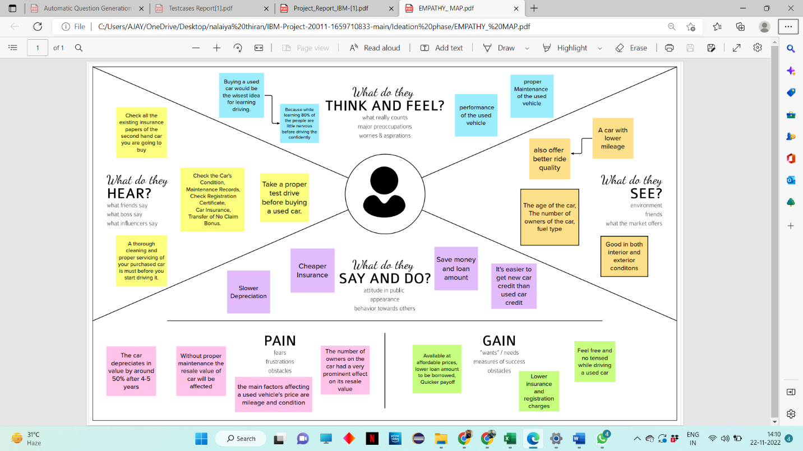

* 1. **Ideation & Brainstorming**

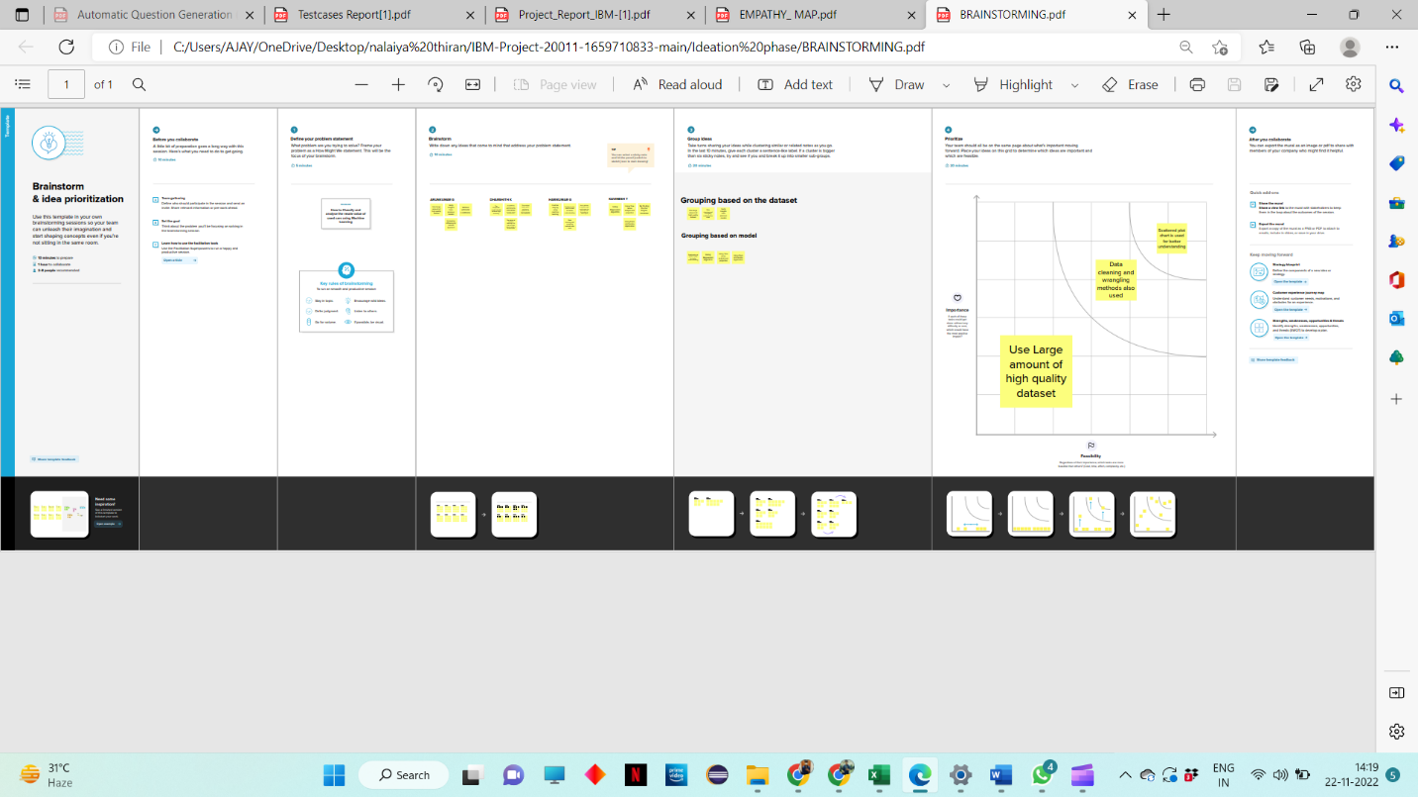

* 1. **Proposed Solution**

|  |  |  |
| --- | --- | --- |
| **S. No.** | Parameter | Description |
| 1. | Problem Statement (Problem to be solved) | • The main aim of this project is to predict the price of used cars using the various Machine Learning (ML) models.  • The project should take parameters related to used car as inputs and enable the customers to make decisions by their own. |
| 2. | Idea / Solution description | • The model is to be built that would give the nearest resale value of the vehicle. By using these best accuracy value will be taken as a solution and it will be integrated to the web-based application where the user is notified with the status of his product. |
| 3. | Novelty / Uniqueness | Used car price prediction is effectively used to determine the worthiness of the car by their own within few minutes by using various features such as year, model, mileage(km), etc. |
| 4. | Social Impact / Customer Satisfaction | • If the user wants to buy or sell a own car it helps users to predict the correct valuation by their own.  • A loss function is to be optimized and mainly a weak learner can make predictions for used cars easily. |
| 5. | Business Model (Revenue Model) | • It helps users to predict the correct valuation of the car remotely with perfect valuation and without human intervention like car dealers in the process to eliminate biased valuation predicted by the dealer. |
| 6. | Scalability of the Solution | • Using Stored data and machine learning approaches, this project proposed a scalable framework for predicting values for different type of used cars present all over India |

* 1. **Problem Solution fit**

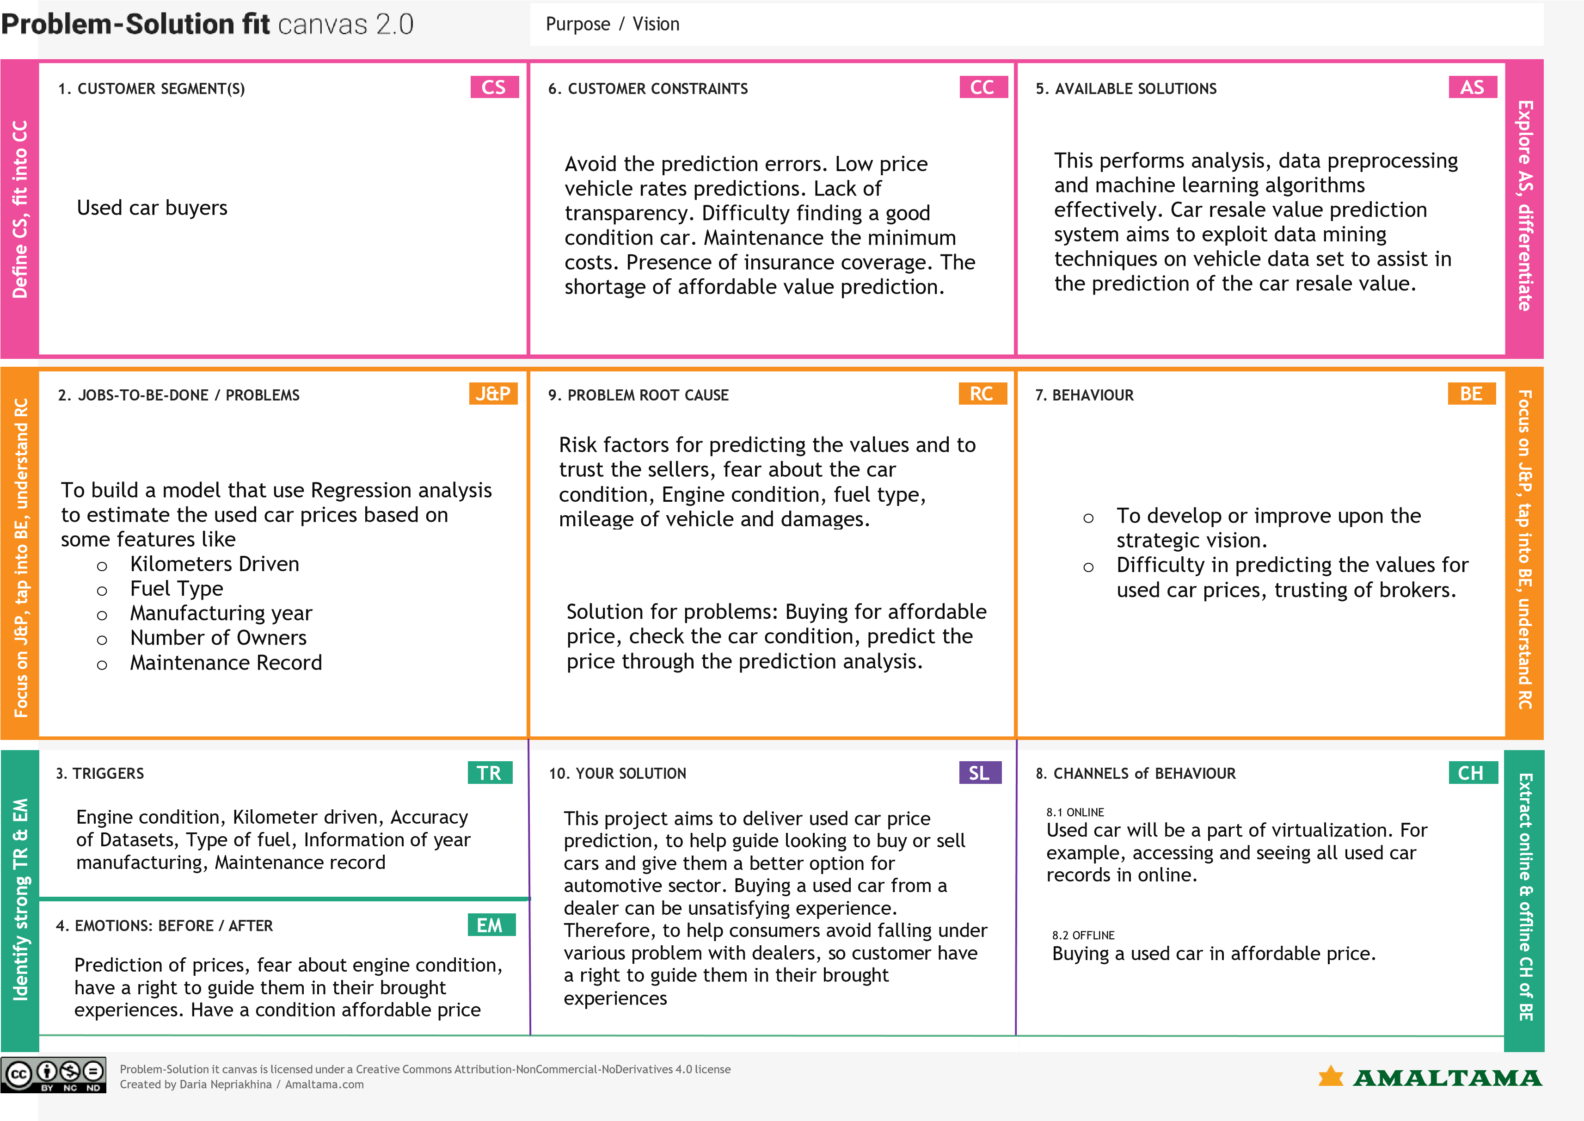

1. **REQUIREMENT ANALYSIS**

**4.1 Functional requirement**

|  |  |  |
| --- | --- | --- |
| **FR .NO** | **Functional Requirement (pic)** | **Sub Requirement (Story / Sub-Task)** |
| FR -1 | User Registration | Registration through Form  Registration through Gmail  Registration via LinkedIN |
| FR -2 | User Confirmation | Confirmation via Email Confirmation via OTP |
| FR-3 | User’s vehicle detail | Manufacturing year , model , kms driven ,fuel type, registration number etc. |

**Non-functional Requirements:**

|  |  |  |
| --- | --- | --- |
| **FR No.** | **Non-Functional Requirement** | **Description** |
| NFR 1 | **Usability** | Simple and a friendly UI that  makes a seamless  interaction with user |
| NFR 2 | **Security** | Must be a secure from SQL injection and protect from other attackers from stealing data. |
| NFR 3 | **Reliability** | A reliable source where the user details are encrypted and secured from attackers**.** |
| NFR 4 | **Performance** | The user interface must be able to hold a reasonable amount of network traffic  and have a high performance speed**.** |
| NFR 5 | **Availability** | The webpage must not crash due to network traffic and must be available for user at anytime. |
| NFR 6 | **Scalability** | It must be capable of moving from a smaller to a larger OS and take full advantage of the larger OS and the large number of user that could be handled**.** |

**5.PROJECT DESIGN**

**5.1 Data Flow Diagrams**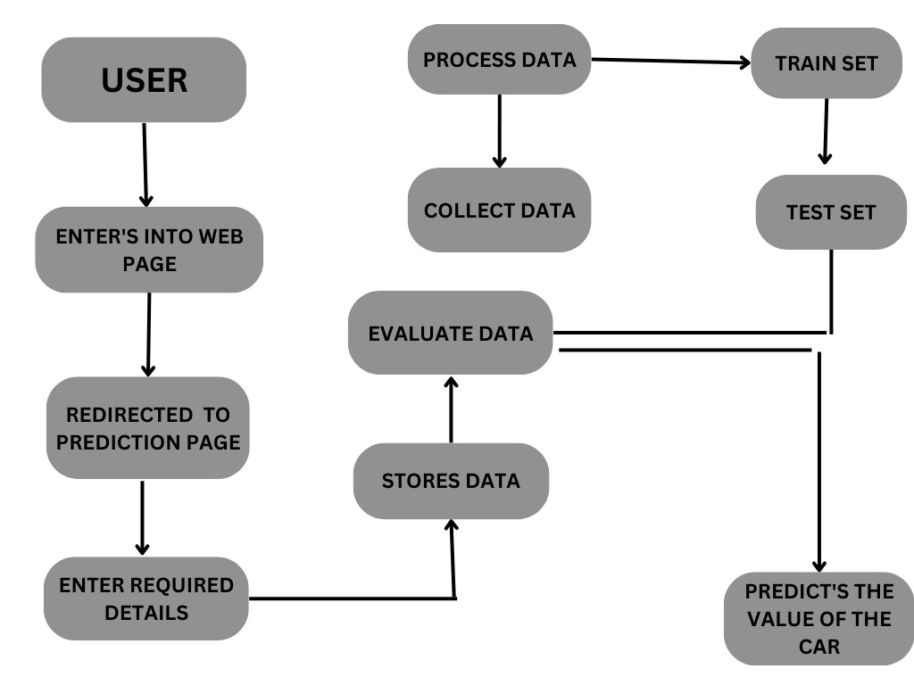

**5.2 Solution & Technical Architecture**

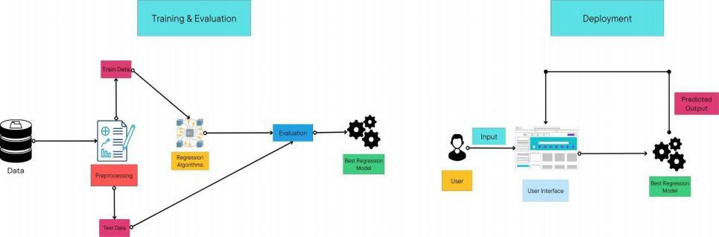

* 1. **User Stories**

|  |  |  |  |  |  |  |
| --- | --- | --- | --- | --- | --- | --- |
| User Type | Functional  Requirement  (epic) | User story  number (S .NO) | User Story /Task | Acceptance  criteria | Priority | Release |
| Customer( web user) | Enter ‘s into the browser | USN -1 | As a user, I can access to website using any web browser | I can enter by selecting the appropriate web link in the browser. | High | Sprint 1 |
| -Any user - |  | USN-2 | As a user, I can proceed to the prediction page by selecting the check value button in the home page. | I can enter into it  without any  acceptance  . | High | Sprint 1 |
| Customer*  (if in case mobile user | Enter ’s into a mobile browser | USN-3 | As a user, I can use any of the appropriate mobile browser to enter into the website. | I can enter by using an appropriate web link. | Medium | Sprint 1 |
| Customer Care  Executive | Giving a missed  call |  | Drop a query ,we will get back to you. |  |  |  |

**6 .PROJECT PLANNING & SCHEDULING**

**6.1 Sprint Planning & Estimation**

|  |  |  |  |  |  |
| --- | --- | --- | --- | --- | --- |
| **Sprint** | **Functional (Requirem ents)** | **User**  **Story**  **Number** | **User story/Task** | **Story points** | **Priority** |
| Sprint 1 | Home page | USN 1 | As a user, I can view the home page of the web application. | 20 | Low |
| Sprint 2 | Car resale value display | USN 2 | As a user, I can be redirected to the data entry page. | 20 | medium |
| Sprint 3 | Required data entry | USN 3 | As a user, I can enter my car details in the required fields. | 20 | medium |
| Sprint 4 | Resale vale prediction | USN 4 | As a user, I expect the application to predict the resale value of my car. | 20 | medium |

* 1. **Sprint Delivery Schedule**

|  |  |  |  |  |  |  |
| --- | --- | --- | --- | --- | --- | --- |
| Sprint | Total Story  Points | Duration | Sprint Start Date | Sprint End Date  (Planned) | Story Points  Completed (as on Planned End Date) | Sprint Release Date  (Actual) |
| Sprint-1 | 20 | 6 Days | 24 Oct 2022 | 29 Oct 2022 | 20 | 28 Oct 2022 |
| Sprint-2 | 20 | 6 Days | 31 Oct 2022 | 05 Nov 2022 | 20 | 04 Nov 2022 |
| Sprint-3 | 20 | 6 Days | 07 Nov 2022 | 12 Nov 2022 | 20 | 11 Nov 2022 |
| Sprint-4 | 20 | 6 Days | 14 Nov 2022 | 19 Nov 2022 | 20 | 18 Nov 2022 |

**7. CODING & SOLUTIONING (Explain the features added in the project along with code)**

* 1. **Feature 1**

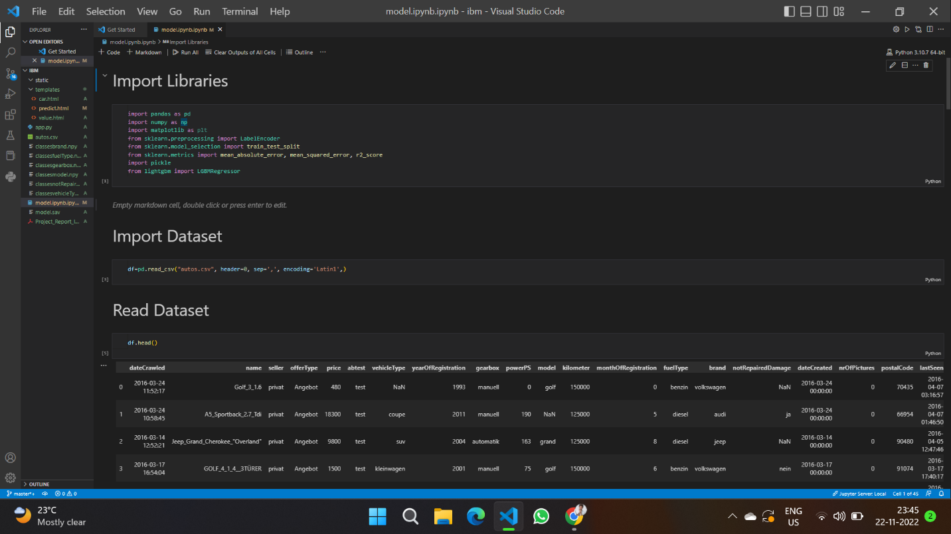

* 1. **Feature 2**

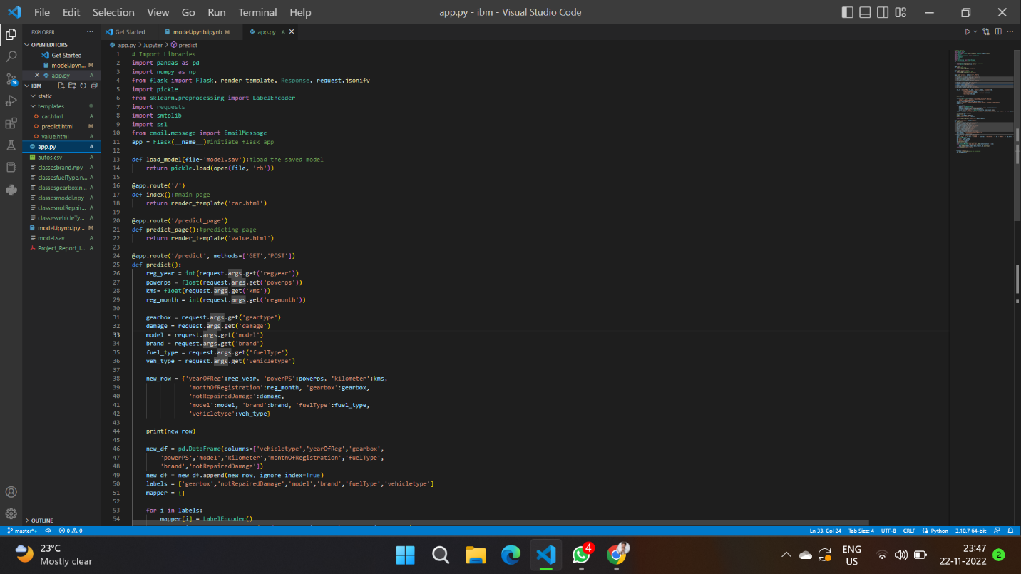

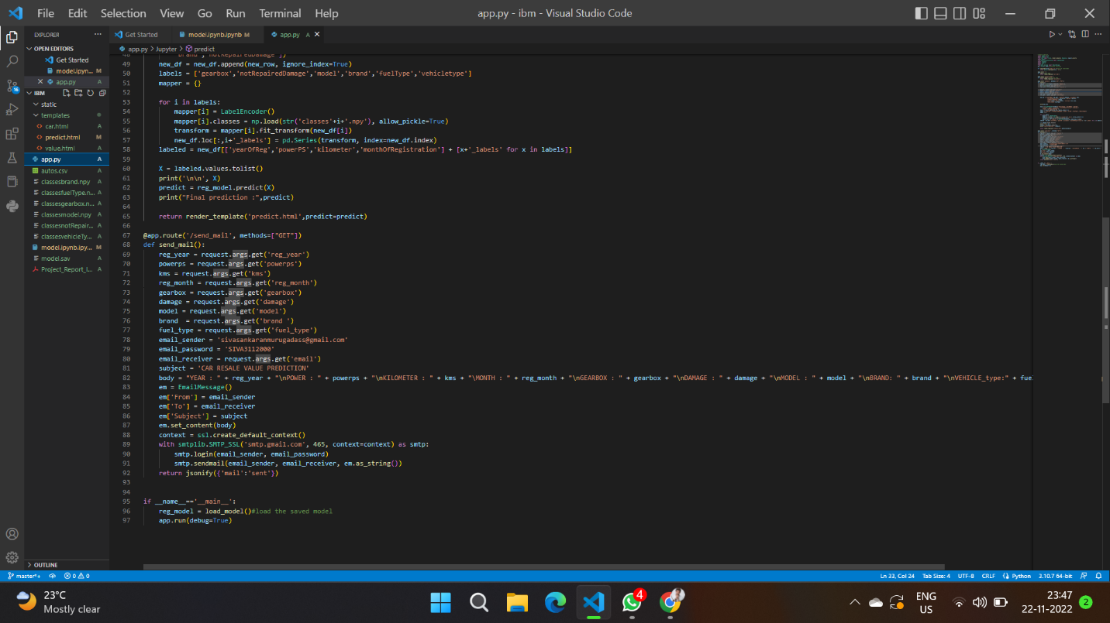

**8.TESTING**

**8.1 Test Cases**

|  |  |  |  |  |  |  |  |  |  |  |  |  |  |  |  |  |
| --- | --- | --- | --- | --- | --- | --- | --- | --- | --- | --- | --- | --- | --- | --- | --- | --- |
| **Testcase ID** | **FeatureType** |  |  | **Component** | **TestScenario** | **Pre-Requisite** | **StepsTo Execute** | **TestData** | **ExpectedResult** | **Actual Result** | **Status** | **Comments** | **TCfor Automation(Y/N)** | **BUG ID** | **ExecutedBy** | |
| HomePage_TC_001 | UI |  |  | HomePage | Verify all the UI elements in Home page rendered properly |  | 1. Enter URL and click go 2. Verify all the UI elements displayed or not | - | All the UI elements rendered properly | Workingas expected | Pass |  | N |  | KAMALRAJ K | |
| HomePage_TC_002 | Functional |  |  | HomePage | Verifiy the Data Entry page can be reachable. |  | 1. Enter URL and click go 2. Verify all the UI elements displayed or not.   3.Press the Check Price button. | - | Usershould navigate to Data Entry  Page | Workingas expected | Pass |  | N |  | SIVASANKARAN M | |
| DataEntryPage_TC_001 | UI |  |  | Data Entry  Page | Verify all the UI elements in Data  Entry page rendered properly |  | 1.Enter URL and click go  2.Verify all the UI elements displayed or not. 3.Press the Check Price button in the home page  4. Verify all the UI elements displayed or not | - | All the UI elements rendered properly | Workingas expected | Pass |  | N |  | VIJAY P | |
| DataEntryPage_TC_002 | Functional |  |  | Data Entry  Page | Verifyuser is able to enter all values |  | 1.Enter URL and click go  2.Verify all the UI elements displayed or not. 3.Press the Check Price button in the home page   1. Verifyall the UI elements displayed or not 2. Verify if all values can be entered | 2019  10  1000  10000  Automatic  Yes  2 Reihe  Smart  CNG  Limousine | User should be able to enter all values in data entry page | Workingas expected | Pass |  | N |  | YOGAN C B | |
| DataEntryPage_TC_003 | Functional |  |  | Data Entry Page | Verifiy theOutput Display page can be reachable. |  | 1.Enter URL and click go  2.Verify all the UI elements displayed or not. 3.Press the Check Price button in the home page   1. Verifyall the UI elements displayed or not 2. Verify if all values can be entered 3. Press thesubmit Button | - | Usershould navigate to Output  Display Page | Workingas expected | Pass |  | N |  | YOGESH N | |
| OutputDisplayPage_TC_001 | UI |  |  | Output DisplayPage | Verify all the UI elements in  Output Display page rendered properly |  | 1.Enter URL and click go  2.Verify all the UI elements displayed or not. 3.Press the Check Price button in the home page   1. Verifyall the UI elements displayed or not 2. Verify if all values can be entered 3. Press thesubmit Button 4. Verifyall the UI elements displayed or not | - | All the UI elements rendered properly | Working as expected | Pass |  | N |  | SIVASANKARAN M |
| OutputDisplayPage_TC_002 | Functional |  |  | Output DisplayPage | Verify user is ableto get predicted result |  | 1.Enter URL and click go  2.Verify all the UI elements displayed or not. 3.Press the Check Price button in the home page   1. Verifyall the UI elements displayed or not 2. Verify if all values can be entered 3. Press thesubmit Button 4. Verifyall the UI elements displayed or not 5. Verifyif the predicted valueis displayed or not | - | Predited Car Resale Value is displayed on the page | Working as expected | Pass |  | N |  | KAMALRAJ K |

Test Scenarios :

Verify user is able to see home page?

Verify user is able to navigate to data entry page?

Verify user is able to see data entry page?

Verify user is able to enter values in the fields?

Verify user is able to navigate to output display page?

Verify user is able to view the output display page?

**8.2 User Acceptance Testing**

Defect Analysis

|  |  |  |  |  |  |
| --- | --- | --- | --- | --- | --- |
| **Resolution** | **Severity 1** | **Severity 2** | **Severity 3** | **Severity 4** | **Subtotal** |
| By Design | 10 | 4 | 2 | 3 | 20 |
| Duplicate | 1 | 0 | 3 | 0 | 4 |
| External | 2 | 3 | 0 | 1 | 6 |
| Fixed | 11 | 2 | 4 | 20 | 37 |
| Not Reproduced | 0 | 0 | 1 | 0 | 1 |
| Skipped | 0 | 0 | 1 | 1 | 2 |
| Won't Fix | 0 | 5 | 2 | 1 | 8 |
| Totals | 24 | 14 | 13 | 26 | 77 |

Test Cast Analysis

|  |  |  |  |  |
| --- | --- | --- | --- | --- |
| **Section** | **Total Cases** | **Not Tested** | **Fail** | **Pass** |
| Print Engine | 7 | 0 | 0 | 7 |
| Client Application | 51 | 0 | 0 | 51 |
| Security | 2 | 0 | 0 | 2 |
| Outsource Shipping | 3 | 0 | 0 | 3 |
| Exception Reporting | 9 | 0 | 0 | 9 |
| Final Report Output | 4 | 0 | 0 | 4 |
| Version Control | 2 | 0 | 0 | 2 |

**9. RESULTS**

**9.1 Performance Metrics**

**{'mae': 1235.112086905962,**

**'mse': 9377053.62710202,**

**'rmse': 3084.6815065692977,**

**'rmsle': 8.43744027403009,**

**'r2': 0.8361221626879432,**

**'adj_r2_score': 0.8261152969113608}**

The model is tested with the various damaged car images which is not used during the training and validation of the model which also shows that the model works with the accuracy of about 98% in the overall performance

**10. ADVANTAGES & DISADVANTAGES**

● To develop an efficient and effective model which predicts the price of a used car according to the user's inputs and achieve good accuracy

**CONS:**

● Less effective

**11. CONCLUSION**

The increased prices of new cars and the financial incapability of the customers to buy them, Used Car sales are on a global increase. Therefore, there is an urgent need for a Used Car Price Prediction system which effectively determines the worthiness of the car using a variety of features. The proposed system will help to determine the accurate price of used car price prediction.

**12.FUTURE SCOPE**

In future this machine learning model may bind with various websites which can provide real time data for price prediction. Also we may add large historical data of car price which can help to improve accuracy of the machine learning model. We can build an android app as a user interface for interacting with users. For better performance, we plan to judiciously design deep learning network structures, use adaptive learning rates and train on clusters of data rather than the whole dataset

1. **APPENDIX**

**GitHub Repo:**

[**https://github.com/IBM-EPBL/IBM-Project-3961-1658675334**](https://github.com/IBM-EPBL/IBM-Project-3961-1658675334)

**Video Link:**

[**https://drive.google.com/file/d/1E9B_AJ0SjbXFNU88g0BI-cM2ySrOv4bj/view?usp=share_link**](https://drive.google.com/file/d/1E9B_AJ0SjbXFNU88g0BI-cM2ySrOv4bj/view?usp=share_link)

**App.py**

